**Assignment 3 Report**

PHP Code Implementation

1. Using PHP to reuse common elements

* include_once syntax is used to include the content of a PHP file into our other PHP files, and is used for elements on our web pages that are repetitive

Syntax used in web pages:

<header>

<?php include_once("includes/header.php");?>

</header>

<nav>

<?php include_once("includes/nav.php");?>

</nav>

Content of PHP file added:

<ul>

<li><a href="index.php">Home</a></li>

<li>

<div id='navcont'>

Products

<div id='productlist'>

</div>

</div>

</li>

<li><a href="enquiry.php">Enquiry</a></li>

<li><a href="disclaimer.php">Disclaimer</a></li>

<?php

if(isset($_SESSION['logged']) && $_SESSION['logged'] == true){

echo $logout;

echo $view;

}

?>

</ul>

1. Creating database table in MySQL

* The team created a database table in MySQL to store all the form input data

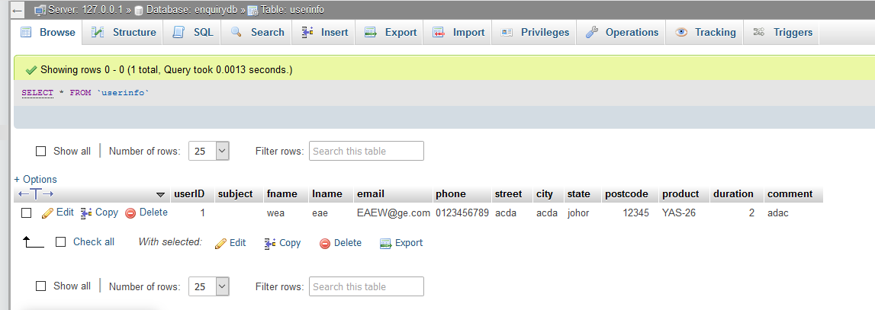

1. Using PHP to validate and process enquiry

* $_POST is used to get form input data by their names(confirm.php)

$subject = $_POST['subject'];

$firstname=$_POST['fname'];

$lastname=$_POST['lname'];

* Using PHP to validate input form data. preg_match checks the variable against an expression to validate the data(enquiry_process.php)

if(isset($_POST['pfname'])){

$firstname = $_POST['pfname'];

$firstname = sanitiseInput($firstname);

if(!preg_match("/^[A-Za-z]+$/", $firstname)){

$err .= "Invalid Firstname<br />";

}

}else{

$err .= "Firstname Empty<br />";

}

* PHP code checks whether there are any errors from form validation, and submits data into a database table using INSERT INTO if there are no errors, or notifies the user that the enquiry has failed if there are errors and displays a message

if($err == ""){

if($conn){

$query = "INSERT INTO userinfo(subject, fname, lname, email, phone, street, city, state, postcode, product, duration, comment)

VALUES('$subject', '$firstname', '$lastname', '$pemail', '$pphone', '$pstreet', '$pcity', '$pstate', '$ppostcode', '$pproduct', '$pduration', '$pcomments')";

$result = mysqli_query($conn, $query);

if($result){

echo "<h2>Your enquiry has been sent to us successfully! Thank You!</h2>";

echo "<h2>To view all enquiries, go to <a href='view_enquiry.php'>View Enquiries</a></h2>";

}else{

echo "Your Enquiry has failed, please try again.";

}

}else{

die("Connection FailedL " . mysqli_connect_error());

}

}else{

echo "<p>" . $err . "</p>";

}

1. Using php to view enquiries

* PHP code in view_enquiry.php gets data from the database table called userinfo using SELECT * FROM table, and echoes the data obtained from the database in a table.

$query = "SELECT * FROM userinfo";

$result = mysqli_query($conn, $query);

if($result){

$row = mysqli_fetch_assoc($result);

if($row){

echo "<table id='enquiry_table'>";

MySQL database structure

For the teams’s MySQL database, there are two tables, userinfo for processed data from enquiry forms, and usertable from user registration.

For the existence of the databases, when entering every page, the php code checks for the existence of the database and the tables. If present, it continues running, if absent, it creates the database and the tables.

Userinfo table



Stores data of incremental user ID, subject, user name, last name, email, phone number, street, city, state, postcode, product, duration of rental, and comments.

Usertable table

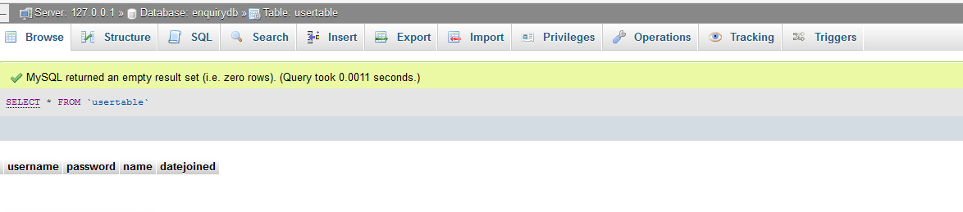

Stores data of user registration name, password, name, and date of registration

Enhancements

The team implemented a user management module, which includes a registration system, which saves the user’s information into the database under the table ‘usertable’. A login is also used to match the username and password to the ones in the database to initiate login. Session super globals were also used to keep track of if the user is logged in or not, which, if they are, member only links are displayed, and some links are changed. For example, the registration link is changed to an edit profile link instead. Users are also allowed to view other members (only the name and the date they joined to prevent a breach of security and personal information), allowed to edit their name by changing it in the database, and also relinquish their membership if they wish to, by dropping the values from the database, all using MySQL Queries.

Team members’ contribution

|  |  |
| --- | --- |
| Member | Contribution |
| Ryan Yap Chen-Yen | PHP reuse elements |
| Wong Kah Heng | Created tables in MySQL |
| Wong Jun Jie |  |
| Joel Yeong Wai Hoe |  |

Ryan Yap Chen-Yen

PHP reuse elements for header, footer, banner and navigation bar.

Wong Kah Heng

PHP reuse elements for registration box.

Wong Jun Jie

View enquiries

Joel Yeong Wai Hoe